Lesson Plan 4
Theme of the lesson: Days of the week (2)
Unit:3
Teacher’s name: | Amanzhol A.B
Date: | 23.11.2021
Grade:3 | Number present: absent:
Theme of the lesson: | Days of the week (2)
Learning objectives(s) that this lesson is contributing to: | 3.UE9 know the days of the week, distinguish them, know how to spell  3.UE17 Be able to write sentences, answer questions completely
Lesson objectives: | All learners will be able to: use common present simple forms  Most learners will be able to: use common present simple forms and ask questions  Some learners will be able to: count, use common present simple forms and use short answers appropriately in short, basic exchanges, read and spell out words.
Value link: | Be friendly, respect each other.
Plan:
Part of the lesson/Time | Teacher’s activity | Student’s activity | Assessment | Resources
5 min. | Organization moment:  Good afternoon  Good after noon to you  Good afternoon dear teacher  We are glad to see you!  -Introduction to the purpose of the lesson  -Divide into groups  Wednesday  Friday | “Write a not to…” method helps to start the lesson with telling supporting words to each other.  The aim: To develop Ss writing skills and create friendly atmosphere  Efficiency: By telling the wishes they show their appreciations . | At the organization moment T tries to award active Ss. «The praise» method is used to evaluate Ss with phrases like:  “Good job!  Well done!” | CD player  cards
Pre-learning  Check the homework  7 min. | 1.Liam doesn’t play the quitar.  2.Where do they go on Friday?  3.What time do you get up?  4.Lilly drinks milk in the morning  5.Lilly and Charlie don’t like burgers  6.They play football every day  7.Do you play the violin?  8.He doesn’t go to school on Sundays  9.We get up at 7 o’clock  10.He watches TV in the afternoon | Ss look at the board revise key phrases, grammar and start to taking interview  Try to speak with different Ss.  Practice Present Simple tense  Aim: Revise the previous lessons material. Find out how much do they remember.  Efficiency: Ss refresh their mind before starting new theme. | Descriptor:  -know key phrases  - can make sentence  - know vocabulary of previous lesson.  Total: 1point | Whiteboard  Cards  Pupils Book
Middle of the lesson  3 min.  2 мin.  3 min | Ex21 p42  -Watch the video  -reading  - Group discussion of issues  - Using the AB method, two children from the group answer the questions. | 1.What time does Lilly get up on Sunday?  - Lilly gets up at ten on Sunday  2.Does Lilly swim in the park?  - Yes, with Nanny and Liam  3.What time does Lilly have lunch on Sunday?  - At one o’clock  4.What does Lilly do on Sunday afternoon?  -lilly watching tv and listening to music sunday afternoon | Descriptor:  -understand general idea  -answer the questions  Total: 1point | Whiteboard  Pupils Book  Flashcards
 | «Days of week» sing a song and dance .  Any video from YouTube. | Ss sing a song and dance.  Vocabulary revision. | T praise active Ss with phrases such as: “Good job!  Well done!” “One more time, please” | Whiteboard  Pupils Book  Poster
Warm up  2 min. | Repeat for video | Repeat for video
Group task  4 min  protection of group tasks  2 min | Сrossword  Two groups are given a crossword puzzle from there to find words and compose a sentence | children will search for words and find
Sing a song about the days of the weeks  2 min | If you’re happy and you know it, clap your hands!  If you’re happy and you know it, clap your hands!  If you’re happy and you know it,  Then your face will surely show it.  If you’re happy and you know it, clap your hands! | children repeat | Descriptor:  -use key words-1point.  -make a dialogue1point.  -Ask and answer the questions -1point. | Whiteboard  Pupils Book  Poster.
«Конверт әдісі»  3 min | helps children choose an envelope from answering questions  -What day is it today?  What’s your favourite day?  -On which days have you got your English lessons?  -What day is it today? Tell me what did you do today?  -What day is it tomorrow?  -On which days have you got school? | children choose an envelope and answer those questions | Descriptor:  Speak on the theme “My week”,  -can describe everyday activity  -can new grammar - 2points.  Ss evaluate each other and encourage classmate with phrases like:  Well done! Brilliant! Good job! I like it! | Whiteboard  Pupils Book Poster: Success Ladder.
“The tangled letter method”  3 min | M n o a d y - Monday  Wendesyad -Wednesday  Teusday -Tuesday  Frydai -Friday  Snudya -Sunday  Satrudya -Saturday | children do the task | Descriptor:  -use key words-1point.  -make a dialogue1point.  -Ask and answer the questions -1point. | Whiteboard  Pupils Book Poster: Success Ladder.
lesson statement  Control questions  - min | 1Name the days of the weeks in turn  (Monday,Tuesday,Wednesday,Thurday, Friday,Saturday,Sunday  2. which days are considered days off?  [Saturday, Sunday]  3. which day is considered sacred  [Friday  4.]what a lucky day [Wednesday] | children answer test questions | Descriptor:  -use key words-1point.  -make a dialogue1point.  -Ask and answer the questions -1point. | Whiteboard  Pupils Book Poster: Success Ladder.
Lesson summary  Feedback  2 min | 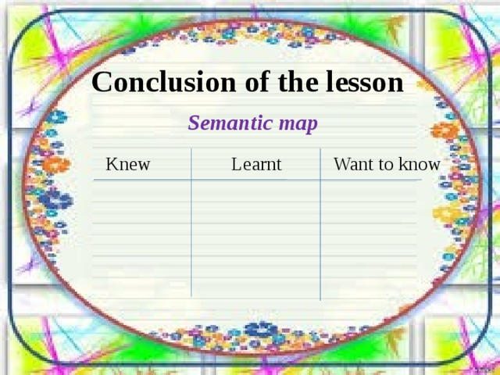 | children write in stickers | Descriptor:  -use key words-1point.  -make a dialogue1point.  -Ask and answer the questions -1point. | Whiteboard  Pupils Book Poster: Success Ladder.

