**Цель урока:** систематизировать и закрепить полученные лексико-грамматические навыки по данной теме и познакомить с новым лексическим материалом.

**Задачи:**

1. Повторить общие и специальные вопросы с глаголами can, do, to be.
2. Познакомить с новыми словами - местами обитания животных: in the garden, in the river, in the forest, in the house, in the zoo.
3. Повторить лексику по теме "Животные", с применением коммуникативного подхода в обучении, используя подвижные игры, загадки, интересные задачи - головоломки.

**Учебно-наглядные пособия:** картинки с изображениями дома, реки, леса, сада, зоопарка; раздаточный дидактический материал; маски животных, вырезанные из бумаги (или настоящие) фрукты, зеркало, магнитофон.

Перед уроком по всему классу развесить следы 9 животных, на которых будет один слог какого-нибудь животного. Например, слово elephant - на трех следах и т.д.  
Стулья учеников стоят по кругу в центре класса (без парт).

**Ход урока**

**1. Организационный момент.**

Teacher: Good morning, dear children!

Pupils: Good morning, our teacher!

Teacher: Are you ready for the lesson?

Pupils: Yes, we are.

Teacher: Fine! I am glad to hear it!

**2. Объяснение целей и задач урока.**

Teacher: Dear boys and girls! Today we are going to travel to a wonderful and beautiful country - a fairy tale. You will not be children there. You will be animals there. We will guess many puzzles, play many games and solve many interesting tasks there. Are you ready to travel?

Pupils: Yes, we are.

Teacher: Close your eyes and let's count from 1 up to 10 all together.

(Ученики закрывают глаза и считают от 1 до 10. В это время учитель одевает им маски.)

**3. Повторение общих и специальных вопросов.**

Teacher: Open your eyes, please. Welcome to the country of Animals. You are not boys and girls. You are animals now.

Pete, stand up and come to me. Look at the mirror. What are you?

Pupil: I'm a tiger.

Teacher: What can you do, tiger?

Pupil: I can run.

Teacher: Do you like to run?

Pupil: Yes, I do.

Teacher: Run, please.

Подобным образом происходит "знакомство" со всеми остальными учениками в классе.

Когда ученики рассядутся, учитель продолжает задавать вопросы:

Where are you from?

How old are you?

How are you?

What do you like?

Do you have a mother?

Would you like to go to Britain? И т.д.

**4. Жаңа сөздермен танысу.**

На доске картинки леса, дома, речки, сада, зоопарка.

Под ними надписи in the forest, in the house, in the river, in the garden, in the zoo.

Teacher: Look at the blackboard. You can see places where you can live. Repeat after me all together.

Мұғалім оқийды,балалар оның артында қайталайды

Балалар жеке айтады.

Содан кейін балалар жаңа сөздері өздері айтады.

Учитель убирает картинку, дети должны сказать, что исчезло с доски.

Затем учитель применяет полученные знания в вопросах:

Tiger, do you live in the river?

Monkey, do you live in the forest?

Mouse, do you live in the house?

Elephant, do you like to live in the zoo?

Cat, do you like to live in the house?

Where do you live, dog?

Where do you live, fox?

Where do you live, parrot? И т.д.

**5. Повторение лексики по теме "Животные", используя подвижные игры, загадки, интересные задачи-головоломки.**

Teacher: Dear animals, let's divide into three groups: yellow, red and orange.

Учитель делит класс на группы, по очереди показывая на ученика и называя yellow, red and orange.

Teacher: Orange, raise your hands! Come here. You are the command of orange. If you will be the first each time you will get an orange.

Yellow, raise your hands! Come here. You are the command of yellow. If you will be the first each time you will get a banana.

Red, raise your hands! Come here. You are the command of red. If you will be the first each time you will get a strawberry.

The first task for you. Look around. There are many tracks of animals in the class. Find your tracks and make up words - the names of the animals. If you are the first - you will be the winner.

Под музыку команды разыскивают следы животных, окрашенных в цвет команды, и составляют слова. Кто справится быстрее, тот получает "фрукт" (свой, для каждой команды).

Подводится итог первого конкурса.

Teacher: Another task for you. I'll give you the envelopes with sentences, which were broken by a cruel wizard. You must make up your sentences from these pieces. Who will be the first - will be the winner.  
Под музыку ученики составляют предложения из отдельных слов, находящихся в специальных конвертиках для каждой команды. Подведение итогов, вручение "фрукта" победившей команде.

Teacher: The last task for you. You made up the text from the pieces of paper. This is a puzzle about animals, as you have understood. Read the puzzle to your friends from other commands and they must guess what animal this is.

Ученики из одной команды читают свою загадку другим командам. Те, кто догадаются - получают свой фрукт.

Подведение общих итогов. Выявление победителей.

Teacher: All the animals of ... command get 5 for today.

And now it's time to sing the song.

Исполнение песни о животных хором под музыку, записанную на магнитофоне.

If you happy and you know it, clap your hand!

If you happy and you know it, clap your hand!

If you happy happy happy happy clap your hands clap your hands!

If you happy and you know it, clap your hand!

Teacher: It's time to come back home. Close your eyes and count from 1 up to 10.

Ученики снимают маски.

Teacher: We are at home at last. Good bye, children!

Pupils: Good bye, our teacher!

[Приложение 1](http://xn--i1abbnckbmcl9fb.xn--p1ai/%D1%81%D1%82%D0%B0%D1%82%D1%8C%D0%B8/501581/pril1.doc)

[Приложение 2](http://xn--i1abbnckbmcl9fb.xn--p1ai/%D1%81%D1%82%D0%B0%D1%82%D1%8C%D0%B8/501581/pril2.doc)

[Приложение 3](http://xn--i1abbnckbmcl9fb.xn--p1ai/%D1%81%D1%82%D0%B0%D1%82%D1%8C%D0%B8/501581/pril3.doc)

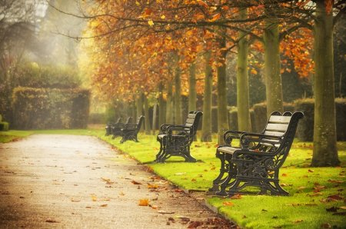 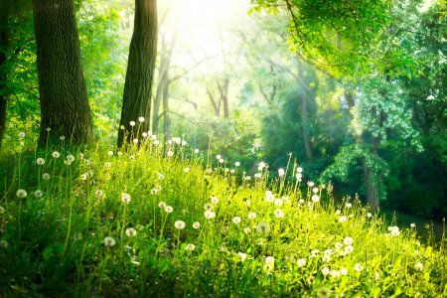

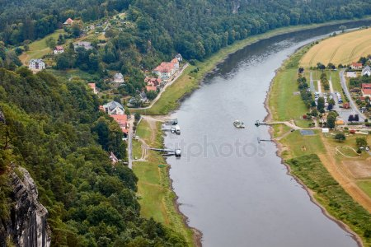 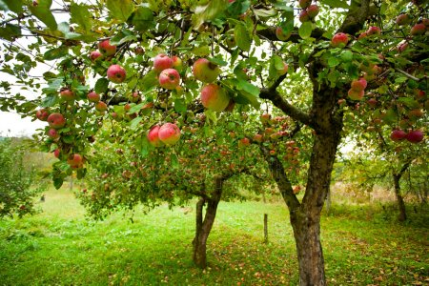 

Приложение 1

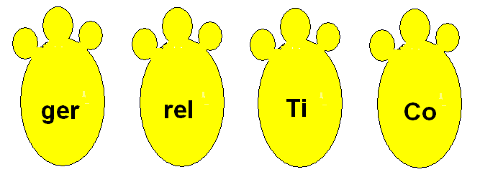

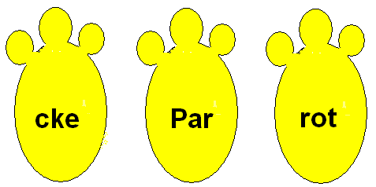

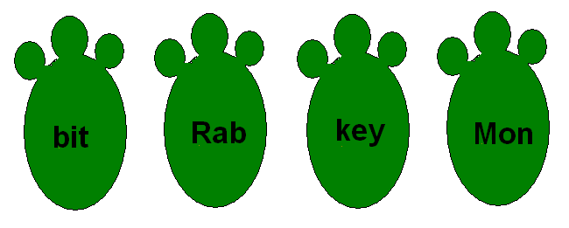

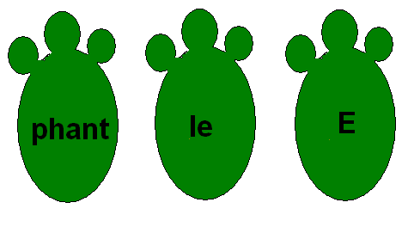

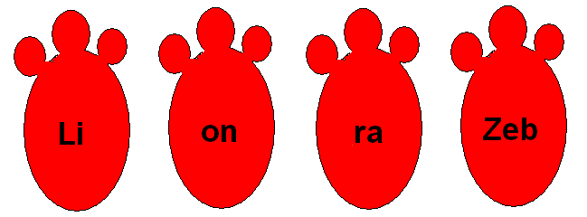

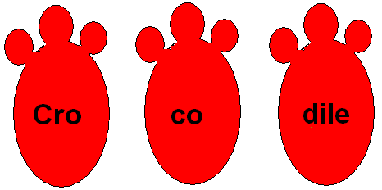

Задание для команды первой.

Составить 5 предложений из разрезанных на бумаге слов. Ответить на вопрос What is it?

|  |  |  |  |  |
| --- | --- | --- | --- | --- |
| 1. I | live | in | the | house. |

|  |  |  |
| --- | --- | --- |
| 2. I | like | milk. |

|  |  |  |  |  |
| --- | --- | --- | --- | --- |
| 3. I | can | jump | and | run. |

|  |  |  |  |
| --- | --- | --- | --- |
| 4. I | do not | like | a mouse. |

|  |  |  |
| --- | --- | --- |
| 5. I | am | nice. |

Задание для команды второй.

Составить 5 предложений из разрезанных на бумаге слов. Ответить на вопрос What is it?

|  |  |  |  |  |
| --- | --- | --- | --- | --- |
| 1. I | am | small | and | brown. |

|  |  |  |  |
| --- | --- | --- | --- |
| 2. I | live | in | Africa. |

|  |  |  |  |  |
| --- | --- | --- | --- | --- |
| 3. I | can | jump | skip | and climb. |

|  |  |  |
| --- | --- | --- |
| 4. I | like | bananas. |

|  |  |  |
| --- | --- | --- |
| 5. I | am | funny. |

Задание для команды третьей.

Составить 5 предложений из разрезанных на бумаге слов. Ответить на вопрос What is it?

|  |  |  |  |  |
| --- | --- | --- | --- | --- |
| 1. I | am | big | and | brown. |

|  |  |  |  |  |
| --- | --- | --- | --- | --- |
| 2. I | live | in | the | forest. |

|  |  |  |  |  |
| --- | --- | --- | --- | --- |
| 3. I | can | run | and | climb. |

|  |  |  |
| --- | --- | --- |
| 4.I | like | honey. |

|  |  |  |  |
| --- | --- | --- | --- |
| 5. I | live | in | the taiga. |

*Hands up, hands down,*

*Hands on hips, sit down,*

*Hands up, to the sides,*

*Bend left, bend right.*

*One, two, three – hop.*

*One, two, three – stop.*

*Stand still.*

Предлагаю отгадать загадки. (tiger, dog, elephant, monkey)

1. *It is not long or big. But it is strong and cunning. It can run and jump. It cannot speak or sing. It likes meat. (tiger)*
2. *It is clever. It can jump and skip. It lives in a tree. It likes sweets. It is funny. (monkey)*
3. *It has many friends. They are boys and girls. It likes to run. It can swim but it doesn’t like to swim in the river. It lives in a house. (dog)*
4. *It likes cabbage and carrots. It is big and strong. But it is not ugly or cunning. It likes to help its friends. It lives in Africa. (elephant)*

Жақсы №1 орта мектебі

**Open lesson**

Theme: «Animals»

Grade: 3 «A»

***Teacher: Anara Kadysabievna Rayeva***

2018-2019ож

Динамическая пауза. Выполнение зарядки под музыку. Песня “Clap-

clap…” [1]